**Assignment 16.1**

**Using Distributed cache join the two datasets and find out the number of temperature variations in each country using mapreduce.**

**Driver :**

In driver use Distributed Cache to put small file which will be taken to all nodes in which mappers is running by setup method

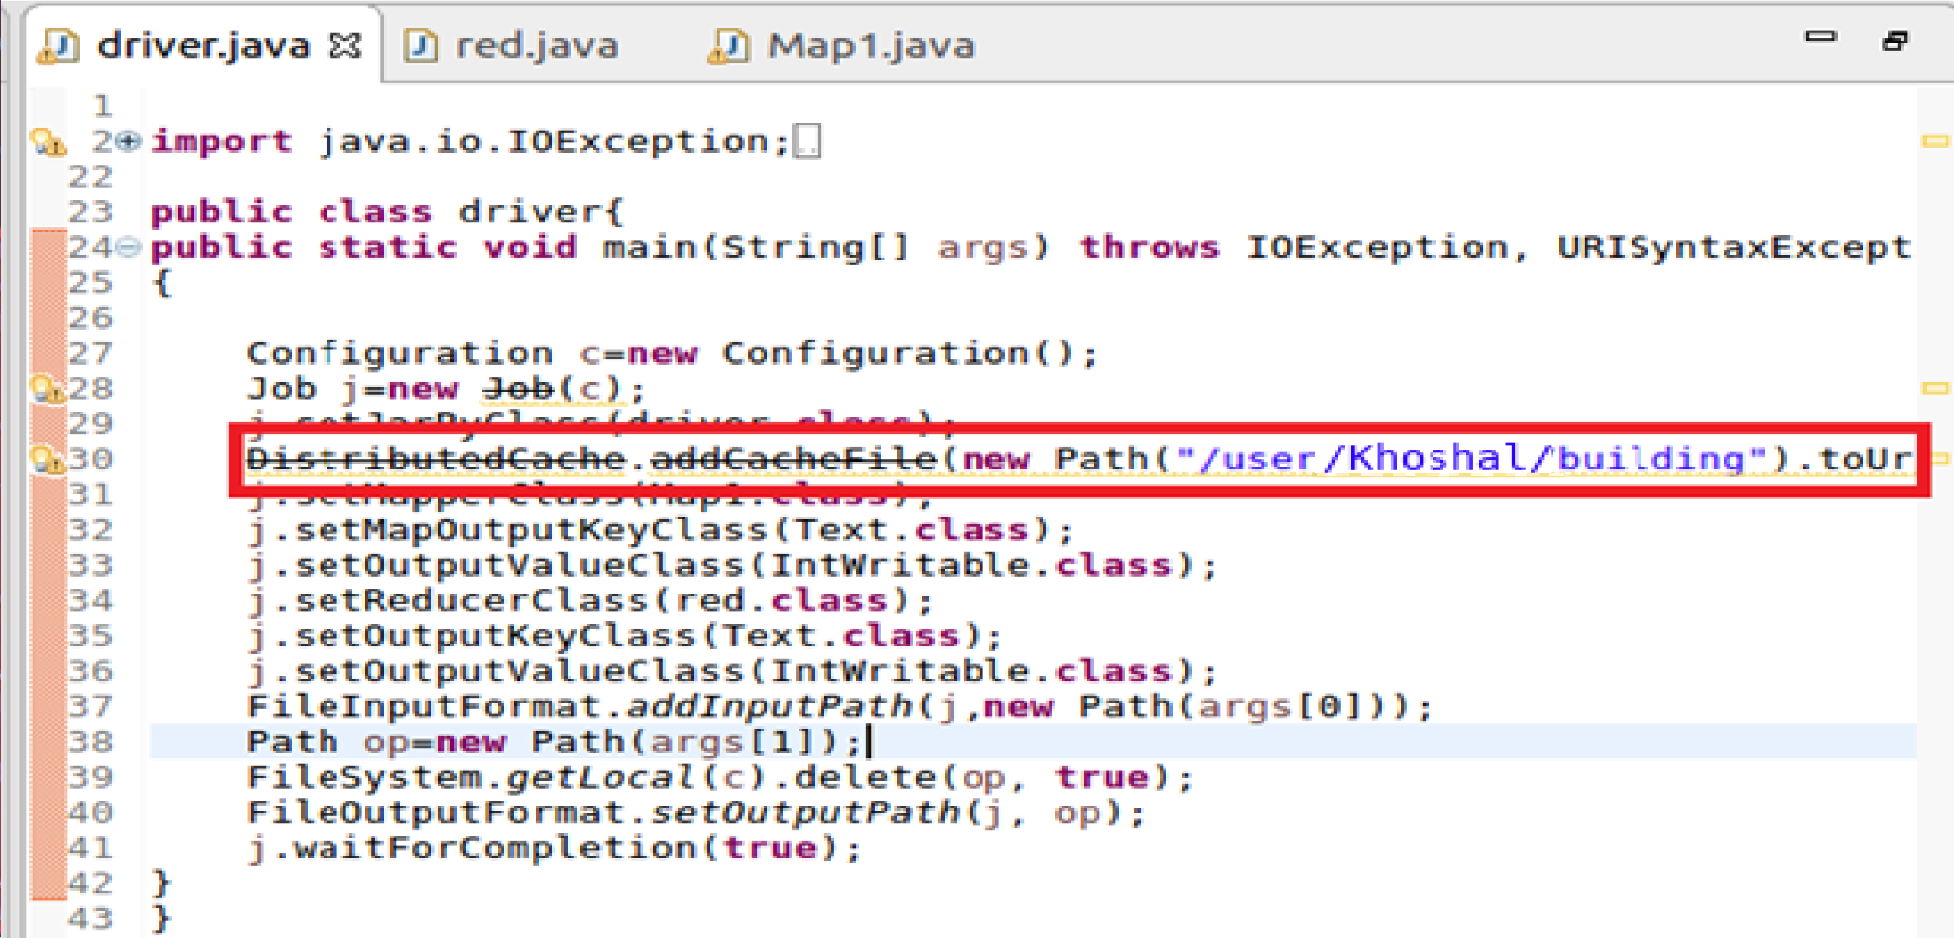

**Mapper:**

**Step1: Overriding Setup Method**

In Mapper override setup method and use Distributed cache.get local and iterate over the path to get the file to get the building

Split the building file by comma and store a hashmap containing Building Id as Key and country as value

**Step2: Overriding Map Method** In this checked for variation(actual temperature not equal to targeted temperature) and then sent the country as key by using (hs.get for corresponding Building Id) and a count of 1 as value

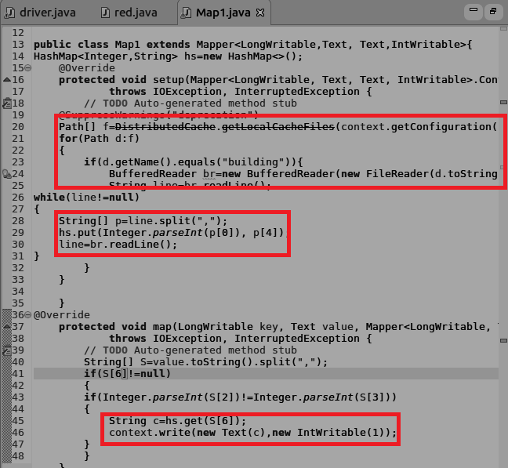

**Reducer:**

In reducer the total count of variation is made by iterating the values

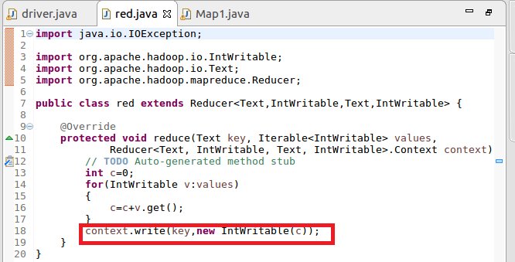

**Running jar**

**Output**

